Grading Guidelines:

A right answer will get full credit when:

1. It is right (worth 25%)
2. It is right **AND** neatly presented making it easy and pleasant to read. (worth an **extra** 15%)
3. There is an **obvious and clear link** between 1) the information provided in the exercise and in class and 2) the final answer. A clear link is built by properly writing, justifying, and documenting an answer (worth an **extra** 60%).
4. Calculation mistakes will be minimally penalized (2 to 5% of full credit) while errors on units will be more heavily penalized.

**Late Submission** : as specified in the syllabus. Days counting starts one minute after the deadline.

You are welcome/encouraged to discuss exercises with other students or the instructor. But, ultimately, **personal** writing is expected.

* USE THIS FILE AS THE STARTING DOCUMENT YOU WILL TURN IN. **KEEP IN THE QUESTIONS** AND INSERT YOUR ANSWERS.
* IF USING HAND WRITING (STRONGLY DISCOURAGED), REWRITE THE QUESTIONS.
* FAILING TO FOLLOW TURN IN DIRECTIONS /GUIDELINES WILL COST A 30% PENALTY.

Objectives of this assignment:

* to learn consider some issues about port numbers
* to explore issues related to the maximum size of TCP segments.

What you need to do:

Answer the questions and/or solve the exercises described below.

KEEP THE GRADING GUIDELINES ABOVE TO REMEMBER THE DIRECTIONS AND HOW THE HOMEWORK IS GRADED.

Objective: The objective of this assignment is to explore some issues about port numbers and largest size of TCP segments.

Resources:

1. **Textbook:** Tanenbaum, Andrew S. and David J. Wetherall. *Computer Networks*.
2. Module 6 lectures
3. Your instructor
4. Wikipedia
5. Internet

Note that the textbook, Module 6 material, and your instructor are sufficient to answer all questions in this homework as well as the related self-study questions.

**Question 1**

Both UDP and TCP use port numbers to identify the destination entity when delivering

a message.

a) (10 points) Can a UDP Server and a TCP Server run simultaneously on the same port # 2500 on the same machine? Explain

b) (20 points) Rather than using a port number to identify the connection, why didn't the designers use the process identifier?

.

**Question 2**

The objective of this question is to determine the largest size of a TCP segment transported by IPv4.

a) (10 points) Does the TCP Header have a field indicating the size of a segment?

b) (10 points) Does the IPv4 Header have a field indicating the size of a ~~segment~~ packet?

c) (10 points) Suppose you just received an IPv4 packet. What is the field/information in this packet that can allow you to determine the size of the TCP segment?

c) (20 points) What is the largest size of a TCP segment transported by an IPv4 packet?

**Question 3**

(20 points) Assume you are using a Unix system (Tux machine for example). Which command should you use to list all active TCP and UDP "connections"? Find the command and use it on a Tux machine. Take a screenshot and report it here.

**What you need to turn in**:

* Electronic copy of this file (including your answers) (standalone). Submit the file as a Microsoft Word or PDF file.
* Recall that answers must be well written, documented, justified, and presented to get full credit.
* How this assignment will be graded:
* A right answer will get full credit when:
* It is right (worth 25%)
* It is right AND neatly presented making it easy and pleasant to read. (worth 15%)
* There is an obvious and clear link between 1) the information provided in the exercise and in class and 2) the final answer. A clear link is built by properly writing, justifying, and documenting an answer (worth 60%).
* Calculation mistakes will be minimally penalized (2 to 5% of full credit) while errors on units will be more heavily penalized.
* You are welcome/encouraged to discuss exercises with other students or the instructor. But, ultimately, personal writing is expected.

**Appendix**: Grading: What is an OBVIOUS and CLEAR LINK?

Here is an example to explain what an **obvious and clear link** is and how we grade your work.

Consider the following problem:

"(100 points) John travels from Auburn to Atlanta in his car at a speed of 60 mph. Leaving at 8am, at what time will John reach Atlanta".

Here are the answers of three students and their scores:

* **Student 1** answers: "9:48am". Student 1 will get 25 points.
* **Student 2**answers : "John will reach Atlanta at 9:48am". Student 2 will get 25+15 = 40 points
* **Student 3** answers: "The time t to travel a distance d at speed v is equal to d/v = d/60mph. The problem does not provide the distance d from Auburn to Atlanta. Based on GoogleMaps, the distance from Auburn to Atlanta is approximately 108 miles (**document is attached**).

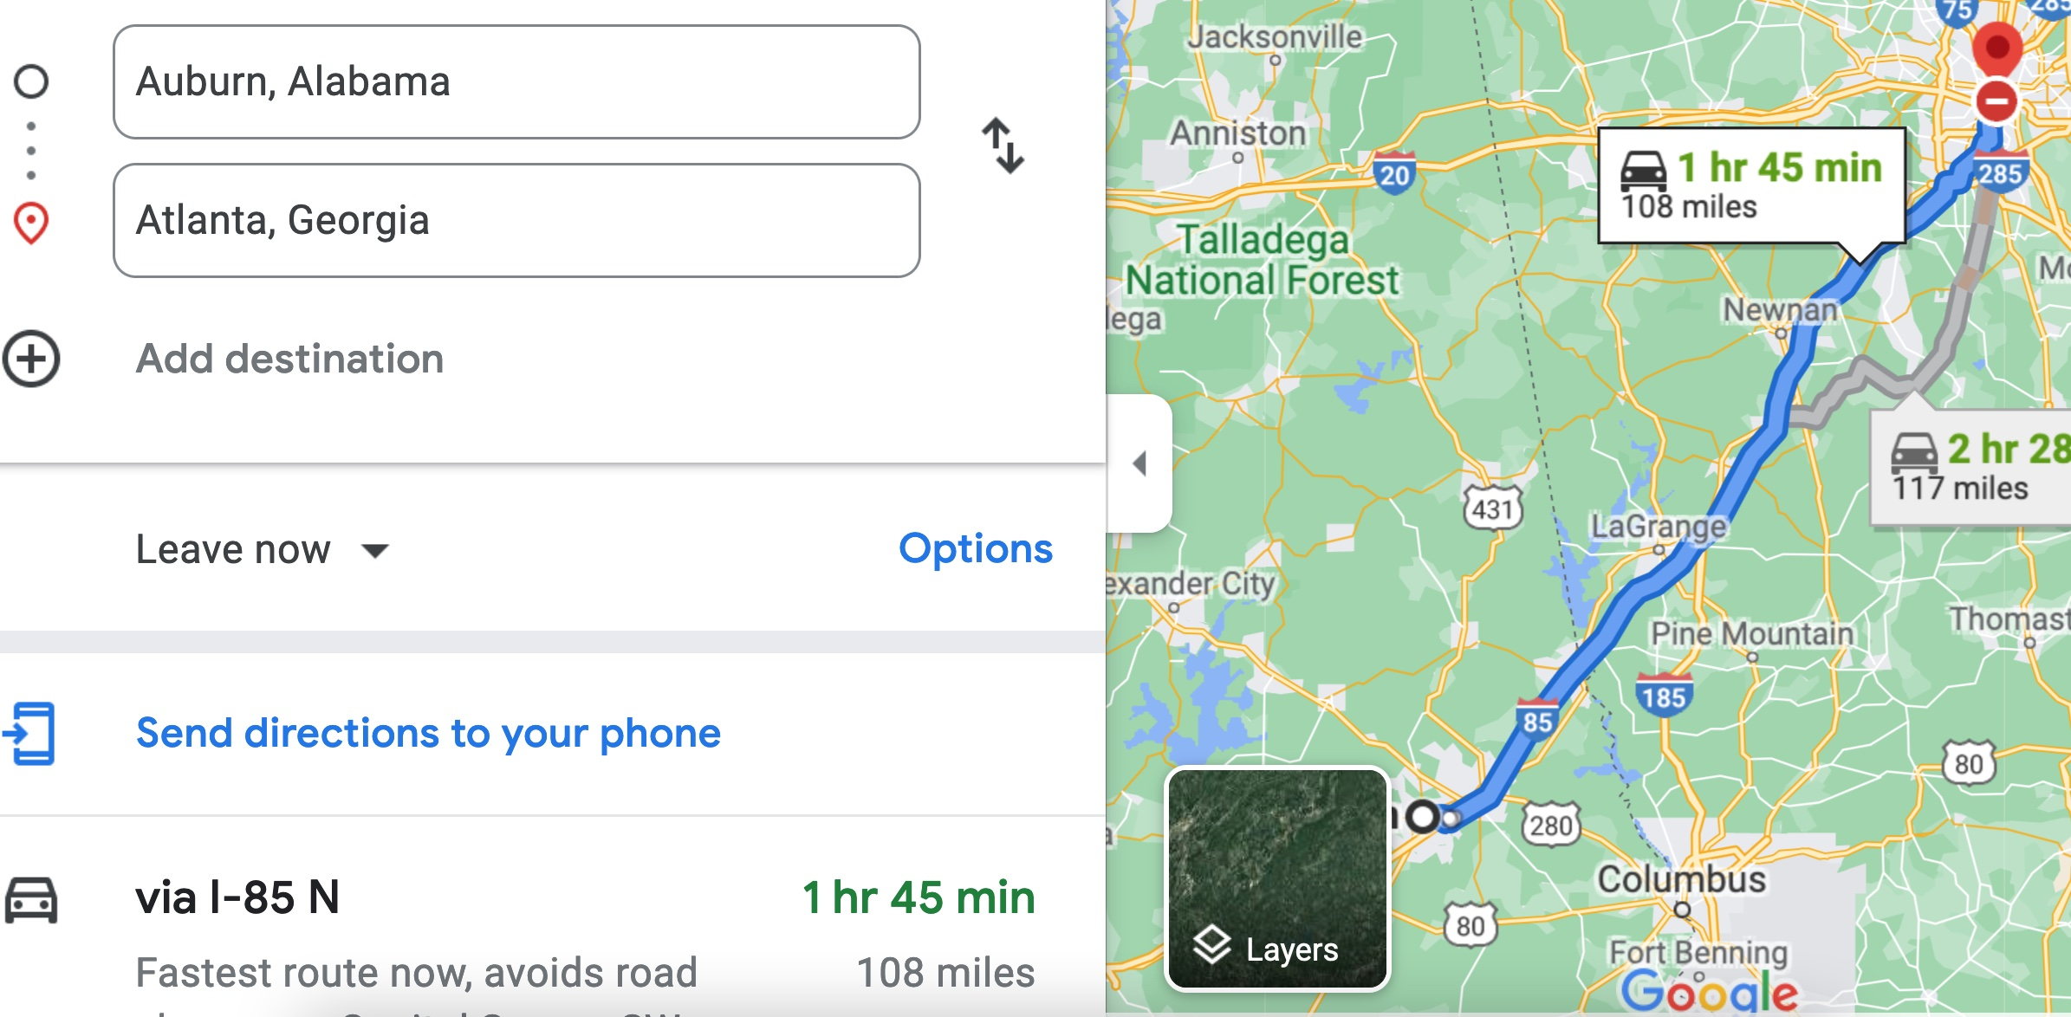

Therefore, the time t = 108 miles/60mph * 60 minutes/hour= 108 minutes. Since John left at 8am, he will then reach Atlanta at 8am + 108 minutes = 8 am + 60 minutes + 48 minutes = 9:48".

**Student 3** will get 25 + 15 + 60 = 100 points

Do you see the **direct** **link** going from the data provided in the question to the final answer, using general knowledge/formula and documents?.... Can you now solve the following problem and get 100 points?

"(100 points) Alice travels from Auburn to Atlanta in her car at a speed of 60 mph. Leaving at 8am, at what time will Alice reach Atlanta assuming that she had a flat tire that delayed her 30 minutes".